

**DOCTOR TO DOCTOR CONSULTATION AND KNOWLEDGE INFORMATION SYSTEM**

**BY : 096802, 101293**

Information Systems Project submitted to the Faculty of IT in partial fulfilment of the requirements for the award of degree of a Degree in Bachelor of Informatics and Computer Science.

**Date of Submission: 31st August 2018**

# Declaration and Approval

We 101293 and 096802 declare that this project has not been submitted to any other University for the award of a Degree in Bachelor of Science in Informatics and Computer Science or any other degree.

Student Number: __________________________________________

Sign: ________________________ Date: ________________________

Student Number: __________________________________________

Sign: ________________________ Date: ________________________

Supervisor Name: _______________________________________

Sign: ________________________ Date: ________________________

# Abstract

Malpractice by medical personnel has grown into a major issue in the health sectors of many developing countries. The act of malpractice can be caused by a simple misdiagnosis or incorrect prescription of drugs. Cases of patients receiving wrong prescriptions and diagnosis have become the norm such as the botched surgeries of the Kenyatta National Hospital that occurred earlier this year. Further investigation into such cases all lead to a major root cause which is the lack of knowledge. Cases medical malpractice would decrease significantly if doctors had means to acquire a better understanding of a patient’s ailment hence give the most correct diagnosis and prescription. The problem emerging from this is the death of patients and the unnecessary use of funds in a case where the wrong method of treatment is used. Such a case was reported in The Standard Newspaper on 12th February 2018 where a lady who was having constipation was diagnosed to have a cyst in her pelvis area and was forced to undergo an unnecessary operation that could have lead to more medical issues or even death. Attempts such as medical conventions or conferences and establishing knowledge sharing systems have failed due to the limited doctor to doctor interaction they have. While most doctors continue to build their knowledge by reading throughout their careers, diseases evolve, and the knowledge acquired from medical books may become obsolete and of no use in the fight against such diseases. We intend to build a web-based application with the sole intent of building the doctor’s knowledge of his craft. A system that will allow doctors from all over the world to virtually meet, converse and share their experiences in the field of medical practice. The system will be tailored to suit every kind of doctor need hence any medical practitioner will be able to seek further knowledge when dealing with a disease the he or she may be unsure about its nature and cause. Doctor’s will also be able to share their knowledge by posting about their experiences in the field that they deem as rare cases hence improving the knowledge of their fellow practitioners.

Table of Contents

Declaration and Approval 2

Abstract 3

Chapter 1: Introduction 7

1.1 Background 7

1.2 Problem Statement 9

1.3 Aim 9

1.3.1 Specific Objectives 9

1.3.2 Research Questions 10

1.4 Justification 10

1.5 Scope and Limitations 10

CHAPTER 2: LITERATURE REVIEW 11

2.1 Introduction 11

2.2 Existing means of sharing knowledge 11

2.3 Challenges Experienced by Doctors using Existing Methods 11

2.4 Existing Consultation Applications and Systems 12

2.5 Gaps in the existing systems 14

Chapter 3: Methodology 15

3.1 Introduction 15

3.2 System Development Methodology 15

i) Business Modeling 15

ii) Data Modeling 15

iii) Process Modeling 16

iv) Application Generation 16

v) Testing and Turnover 16

3.3 System Analysis 17

3.3.1 Functional Requirements 17

3.3.2 Non-functional Requirements 17

3.4 System Design 17

3.4.1 Use Case Diagram 18

3.4.2 Data Flow Diagram 19

3.4.3 Entity Relation Diagram 20

3.4.3 Database Schema 21

3.5 System Development Tools and Techniques 22

3.5.1 Sublime Text Editor 22

3.5.2 MySQL Database 22

3.6 Deliverables 22

3.6.1 Doctors’ Module 22

3.6.2 Admins’ Module 22

Appendix A: GANNT Chart 23

**Table of Figures**

[Figure 1.1 ……………………………………………………………………………………………………………………………………….   7](https://docs.google.com/document/d/1ApmkXjGN8QfJcGy3aiXJF-vbAQO4jF4ZLwOfu26iLGk/edit#heading=h.46r0co2)

[Figure 2 ………………………………………………………………………………………………………………………………………….   8](https://docs.google.com/document/d/1ApmkXjGN8QfJcGy3aiXJF-vbAQO4jF4ZLwOfu26iLGk/edit#heading=h.tyjcwt)

[Figure 3 ………………………………………………………………………………………………………………………………………….   9](https://docs.google.com/document/d/1ApmkXjGN8QfJcGy3aiXJF-vbAQO4jF4ZLwOfu26iLGk/edit#heading=h.1t3h5sf)

[Figure 4   ……………………………………………………………………………………………………………………………………….. 12](https://docs.google.com/document/d/1ApmkXjGN8QfJcGy3aiXJF-vbAQO4jF4ZLwOfu26iLGk/edit#heading=h.z337ya)

[Figure 5 ………………………………………………………………………………………………………………………………………..   13](https://docs.google.com/document/d/1ApmkXjGN8QfJcGy3aiXJF-vbAQO4jF4ZLwOfu26iLGk/edit#heading=h.3j2qqm3)

[Figure 6  ………………………………………………………………………………………………………………………………………..  13](https://docs.google.com/document/d/1ApmkXjGN8QfJcGy3aiXJF-vbAQO4jF4ZLwOfu26iLGk/edit#heading=h.1y810tw)

[Figure 7………………………………………………………………………………………………………………………………………..    16](https://docs.google.com/document/d/1ApmkXjGN8QfJcGy3aiXJF-vbAQO4jF4ZLwOfu26iLGk/edit#heading=h.2p2csry)

[Figure 8 ……………………………………………………………………………………………………………………….………………..  18](https://docs.google.com/document/d/1ApmkXjGN8QfJcGy3aiXJF-vbAQO4jF4ZLwOfu26iLGk/edit#heading=h.1hmsyys)

[Figure 9  ………………………………………………………………………………………………………………………………………..  19](https://docs.google.com/document/d/1ApmkXjGN8QfJcGy3aiXJF-vbAQO4jF4ZLwOfu26iLGk/edit#heading=h.2grqrue)

[Figure 10 ………………………………………………………………………………………………………………………………………   20](https://docs.google.com/document/d/1ApmkXjGN8QfJcGy3aiXJF-vbAQO4jF4ZLwOfu26iLGk/edit#heading=h.3fwokq0)

[Figure 11 ………………………………………………………………………………………………………………………………………   21](https://docs.google.com/document/d/1ApmkXjGN8QfJcGy3aiXJF-vbAQO4jF4ZLwOfu26iLGk/edit#heading=h.4f1mdlm)

# Chapter 1: Introduction

## 1.1 Background

Diseases are known to evolve and become resistant to drugs and treatment. Their symptoms

also evolve with time and may lead to many cases of misdiagnosis. This is often blamed on the

doctor’s lack of knowledge on such diseases and is termed as malpractice. This issue

has led to millions of people losing their ability to have a normal life and in many cases death.

As reported by The Daily Nation on the 17th of October, many maternal deaths are accredited

to doctors failing to take note of mothers in need of urgent care as they approach their due

dates. The doctors also fail to give a correct diagnosis to expectant mothers who fall sick

leading to either the mother or child or both losing their lives. These doctors seem to lack the

required knowledge and skill to help them handle such cases.

A screenshot of a cell phone

Description generated with very high confidence

*Figure 1.1: Rate of maternal deaths in hospitals with their causes (source:Nation,2018)*

In 2017, The Standard Digital reported a similar case occurred where an expectant mother

undergoing an ultrasound could not see the baby on the screen. The doctor carried out a

second ultrasound and reported to themother that she was expecting twins. On her due

date,she was surprised to only receive one baby and was shocked at the doctors total lack

ofknowledge in interpreting data from an ultrasound.

In July 2018, the Kenya Medical Research Institute (KEMRI) reported that out of the 40,000

cancer cases reported 27,000 of them ended in death. They blamed this on poor diagnosis

and poor precription of drugs by the doctors.

A close up of a map

Description generated with high confidence

*Figure 1.2: Rate of reported cancer cases with the death toll. (source:Nyamwaya, .2015)*

KEMRI then advised the Ministry of Health to organise conferences and workshops for the doctors to be better trained and share knowledge among themselves in a bid to curb the number of reported deaths sourcing from misdiagnosis.

This justifies the reason for misdiagnosis is lack of medical knowledge and it leads to the unnecessary use of a patient’s funds and in many cases death.

Developed countries such as the USA, who have had 12 million of their citizens misdiagnosed in the past year, are taking measures to prevent these cases from occurring. According to Dr. Jon LaPook, doctors should be allowed to be registered across multiple medical associations in order to help them to share their knowledge with their fellow practitioners.

## 1.2 Problem Statement

The problem being the death of patients, doctors who lack the knowledge are also affected. The

are reported for malpractice and sued. This tarnishes their reputation and may lead to the end

of their careers. Patients also spend millions every year on medical errors that could have been

prevented if the doctors had the knowledge.

A screenshot of a cell phone

Description generated with very high confidence

*Figure 1.3The cost of correcting medical errors. (source:Indiaclinic. 2016)*

## 1.3 Aim

The aim of this project is to develop a way for medical practitioners to communicate and share

knowledge among themselves in a bid to reduce cases of misdiagnosis and incorrect

prescriptions.

### 1.3.1 Specific Objectives

1. To understand how doctors communicate among themselves.
2. To learn how doctors acquire new knowledge as they are out in the field.
3. To understand what measures doctors take when they face new cases and how they share their knowledge.

### 1.3.2 Research Questions

1. How do doctors communicate?
2. How often do you come across new symptoms?
3. What are the steps taken when you face a new disease?

## 1.4 Justification

Most doctors find that instead of sending patients as referral cases to other doctors, he or she can simply acquire knowledge on the case from more experienced doctors hence boosting his knowledge and saving the time and money of the patient.

## 1.5 Scope and Limitations

This system seeks to serve any doctor who is computer literate, has access to a computer with internet connection. The doctor will be able to read about similar symptoms and post about his or her encounters with evolving diseases.

The limitations are:

1. Every doctor will require access to a computer with internet connection.
2. In a case where a doctor is the first to discover new symptoms of an evolving disease, he or she can only add knowledge to the system but not acquire from it.

# CHAPTER 2: LITERATURE REVIEW

## 2.1 Introduction

Systems have been established to tackle the issue of misdiagnosis and incorrect prescriptions but have failed to significantly do so.

## 2.2 Existing means of sharing knowledge

There are currently two major means of knowledge sharing between doctors. They are conferences and use of systems contracted by medical association networks. An example of such conferences include The First Conference on Liver Disease in Africa set to take place in Nairobi, Kenya from the 13th to 15th of September 2018. Such conferences seek to educate doctors on newly discovered diseases and demonstrate new methods of treatment.

Medical associations, specifically in Asian countries, have contracted knowledge sharing systems to benefit their doctors. Such systems include Docquity, EVOQ Medical and Expert Medical Navigation.

## 2.3 Challenges Experienced by Doctors using Existing Methods

Medical practitioners face the following challenges while using these existing methods.

Doctors are required to travel long distances and leave their work behind to attend medical conferences. An example The First Conference on Liver Disease in Africa which will make doctors leave their places of work in other African countries to convene in Nairobi, Kenya.

Medical practitioners must be registered under a medical association that has contracted a knowledge sharing system to access the services of these system. An example is Docquity which is currently contracted by over twenty medical associations in Asian countries.

Medical knowledge sharing systems that are currently in operation are charging medical associations thousands of dollars every month for them to connect with other doctors on the same network. This renders the service unavailable to developing countries that lack the capital.

## 2.4 Existing Consultation Applications and Systems

**2.4.1 Docquity**

Deemed as the fastest growing medical network. Launched in 2016 by Amit Vithal and Indranil Roychowdhury, Docquity now has more than 60,000 doctors signed onto the app from Malaysia, Indonesia and the Philippines. It also has an index of over 70,000 clinical cases, with five to seven separate discussions around each case.A person wearing a white shirt

Description generated with very high confidence

*Figure 2.1A snapshot from Doquity’s website (source:Docquity.2018)*

**2.4.2 EVOQ Medical**

Incorporated in 2014, it enables physicians and other medical practitioners to create and retrieve meaningful data from clinical electronic health records. It also provides physicians to view multi-location schedules as a consolidated schedule, review complete patient records across providers and electronic health records, document patient encounters, and approve clinical data. The company was and is based in Atlanta, Georgia with additional locations in Panama City Beach, Florida; and Birmingham, Alabama.

A close up of electronics

Description generated with high confidence

*Figure 2.2 A snapshot showing EVOQ Medical’s blynq techn.(source:Evoqmd.2018)*

**2.4.3 Expert Medical Navigation**

Founded in 2009 with the goal of helping patients make better medical decisions while considering what their doctors have already recommended. It is based in Boston, Massachusetts, USA.

A screenshot of a social media post

Description generated with very high confidence

*Figure 2.3A snapshot showing how Expert Medical Navigation operates. (source:Crunchbase.2018)*

## 2.5 Gaps in the existing systems

All but one of these existing systems are limited to one field of medicine and doctor to patient communication. Docquity has made major attempts to include doctors from every field and introduce a post-doctoral learning system that is currently benefiting seven Asian countries. It has made major leaps in improving the reputation of doctors in these countries but has failed in allowing its services to be accessed by individual doctors since it must be contracted by the doctor’s medical association. Docquity also charges these medical associations thousands of dollars every month to allow them to use their services. (DataFox.2018)

EVOQ Medical, a competitor to Docquity has specialized in allowing physicians to document their patient encounters. This leaves all the other fields of medicine without a knowledge database. In addition, EVOQ Medical can only be used on the IOS platform hence its accessibility is limited.

Medical conferences have failed since they can only carter for a relatively small number of medical practitioners. Furthermore, most conferences choose to invite specific medical practitioners instead of allowing anyone to attend the conference. (DataFox.2018)

# Chapter 3: Deliverables Methodology

## 3.1 Introduction

This chapter discusses the introduction, software development methodology and deliverables that will be used to develop the system.

## 3.2 System Development Methodology

A Software Development Methodology is a framework that is used to structure, plan and control the process of developing an information system.

Rapid application development is a software development methodology that uses minimal planning in favour of rapid prototyping. A prototype is a working model that is functionally equivalent to a component of the product.

In the RAD model, the functional modules are developed in parallel as prototypes and are integrated to make the complete product for faster product delivery. Since there is no detailed preplanning, it makes it easier to incorporate the changes within the development process.

RAD projects follow iterative and incremental model and have small teams comprising of developers, domain experts, customer representatives and other IT resources working progressively on their component or prototype.

The most important aspect for this model to be successful is to make sure that the prototypes developed are reusable.

RAD model distributes the analysis, design, build and test phases into a series of short, iterative development cycles.

**Stages of this Model:**

### Business Modelling

The business model for the product under development is designed in terms of flow of information and the distribution of information between various business channels. A complete business analysis is performed to find the vital information for business, how it can be obtained, how and when is the information processed and what are the factors driving successful flow of information.

### Data Modelling

The information gathered in the Business Modelling phase is reviewed and analysed to form sets of data objects vital for the business. The attributes of all data sets are identified and defined. The relation between these data objects are established and defined in detail in relevance to the business model.

### Process Modelling

The data object sets defined in the Data Modelling phase are converted to establish the business information flow needed to achieve specific business objectives as per the business model. The process model for any changes or enhancements to the data object sets is defined in this phase. Process descriptions for adding, deleting, retrieving or modifying a data object are given.

### Application Generation

The actual system is built and coding is done by using automation tools to convert process and data models into actual prototypes.

### Testing and Turnover

The overall testing time is reduced in the RAD model as the prototypes are independently tested during every iteration. However, the data flow and the interfaces between all the components need to be thoroughly tested with complete test coverage. Since most of the programming components have already been tested, it reduces the risk of any major issues.

The following illustration describes the RAD Model in detail.

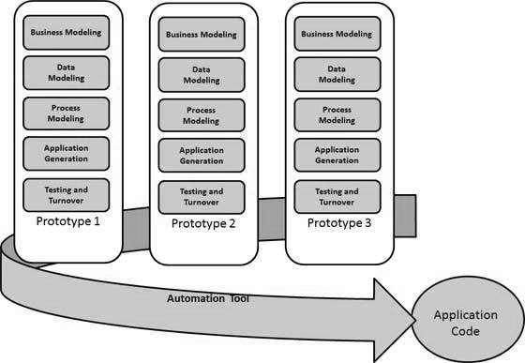

*Figure 3.1 Rapid Application Development Process (source: Tutorialspoint, 2018)*

**3.3 Deliverables**

### 3.3.1 Doctors’ Module

Doctors can login to access existing medical solutions and articles that improves their medical practices. Moreover, they can contact other doctors of a similar category before making an unsure decision or if they want to know more on a certain area of interest.

### 3.3.2 Admins’ Module

The admin can delete accounts and monitor articles that have been added by doctors who are logged into the system.

**3.4 System Development Tools and Techniques**

### 3.4.1 Sublime Text Editor

This text editor enables the system to be coded in the form of PHP, HTML, CSS and JavaScript languages when developing the web application. The doctor and admin in turn will use the web application to view and manipulate data.

### 3.4.2 MySQL Database

A database preferably MySQL database will be used to store majority of the data. For example, user accounts and responses from users.

**3.4.3 Ajax-jQuery Plugin**

The Ajax-jQuery is used to view content in real-time, that is, without refreshing a page. Moreover, it enables a user to search for content which is displayed in a list that is retrieved from the database.

**Chapter 4: System Analysis and Design**

**4.1 Introduction**

System analysis involves examining out how the present system works and identifying the problems that come with it. It also includes looking in-depth at the source code to define the methodologies used in building the system.

**4.2 System Requirements Analysis**

### 4.2.1 Functional Requirements

Functional requirements describe what the software should do in order to accomplish a specific task. A doctor can be able to:

**4.2.1.1 Authentication**

The doctor should be able to login to the system, logout from the system and use passwords in order to access his or her account.

**4.2.1.2 Search**

The doctor can search for doctors within the system. Moreover, he can locate frequently asked questions and look for breakout diseases and quick solutions to cure illnesses.

**4.2.1.3 Question and Answer**

The doctor is able to post a question about an emerging epidemic or new trends of diseases or health concerns. Furthermore, doctors will also be empowered by the system to give answers to these questions.

**4.2.1.4 Send Private Messages**

The doctor can send a message to another doctor who has more experience in a certain speciality so as to ask for advice from the experienced doctor

### 4.2.2 Non-functional Requirements

Non-functional requirements describe the quality characteristics or attributes of the system. They include:

1. Operability – The ability for the system to be kept in a safe and reliable functioning condition
2. Usability – The ability of system to be easily used by a user
3. Availability – The system is committed on the demand to perform a desired function
4. Extensibility – Future growth is considered and catered for by the system.
5. Interoperability – Exchange of specified information is allowed between the software and information systems
6. Scalability - is the capability of a system, network, or process to handle a growing amount of work, or its potential to be enlarged to accommodate that growth.
7. Supportability - the capability of a total system design to support operations and readiness needs throughout the life-cycle of a system at an affordable cost

## 4.3 System Narrative*

## 4.4 System Design

Systems design is the process of defining the architecture, modules, interfaces, and data for the system to satisfy specified requirements.

### 4.4.1 Use Case Diagram

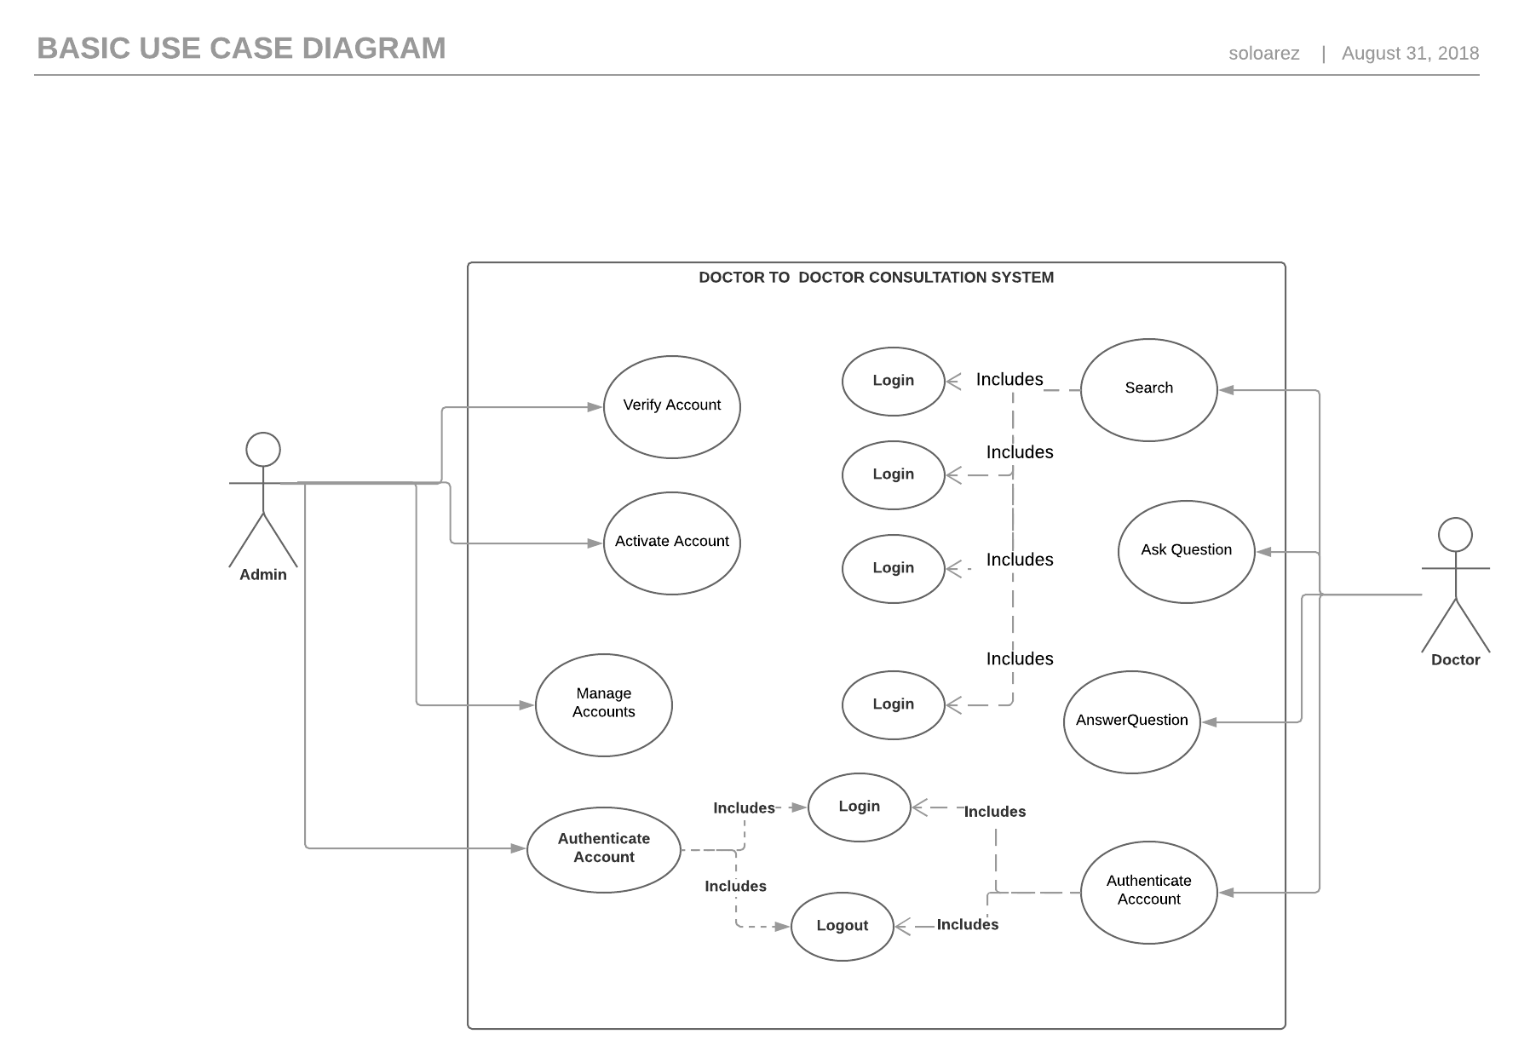

*Figure 3.2 Use Case Diagram*

### 4.4.2 Data Flow Diagram

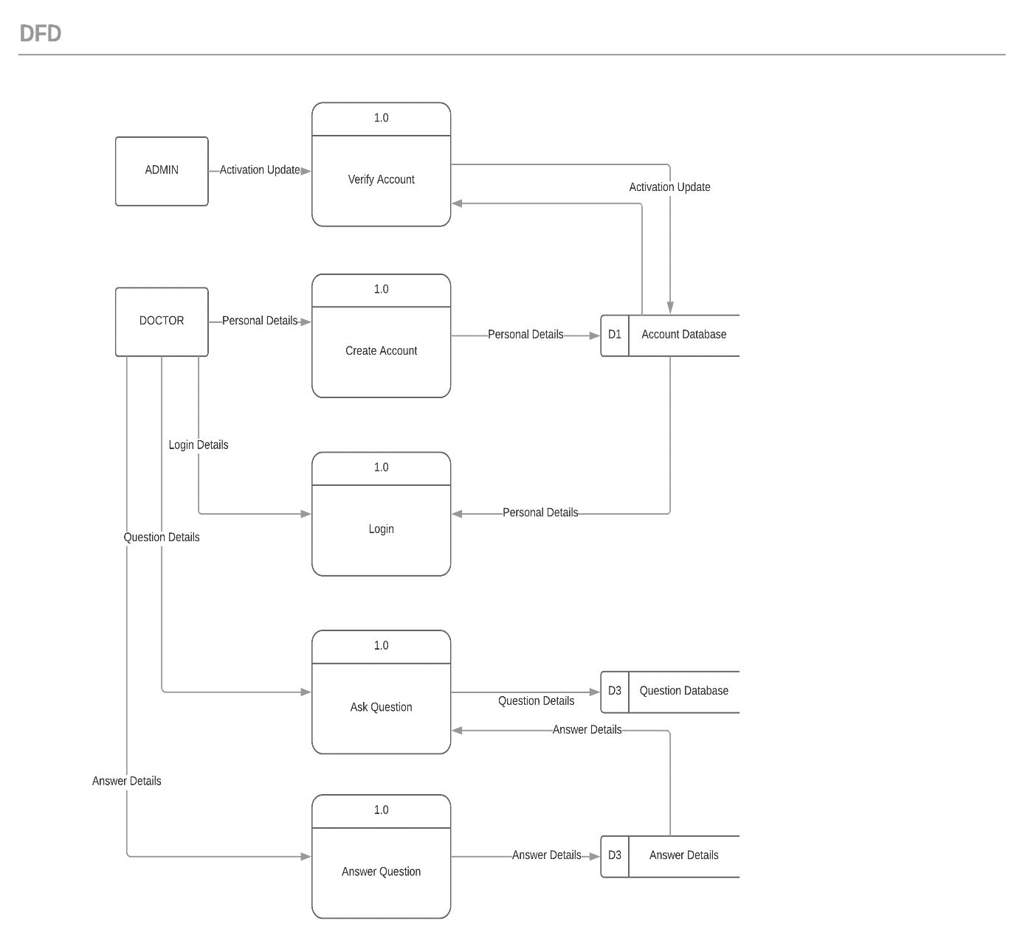

*Figure 3.3 Data Flow Diagram*

|  |  |  |
| --- | --- | --- |
| Personal Details | *Name* | |
| *Address* | |
| *Speciality* | |
| *Identification* | |
| *Login Details* | *Username* | |
| *Password* | |
| *Activation Update* | *YES* | *NO* |

*Table 1.1 Terms Used in the DFD*

### 4.4.3 Entity Relation Diagram

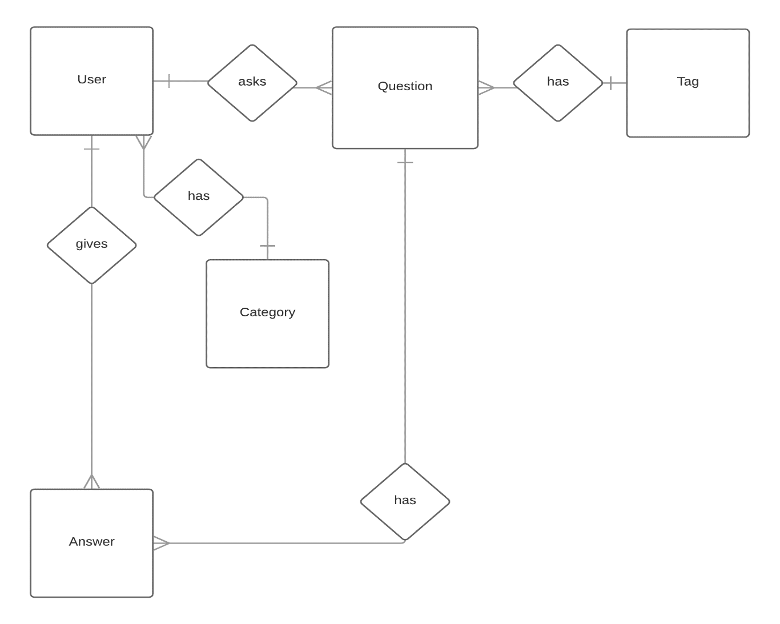

*Figure 3.3 Entity Relation Diagram*

### 4.4.4 Database Schema

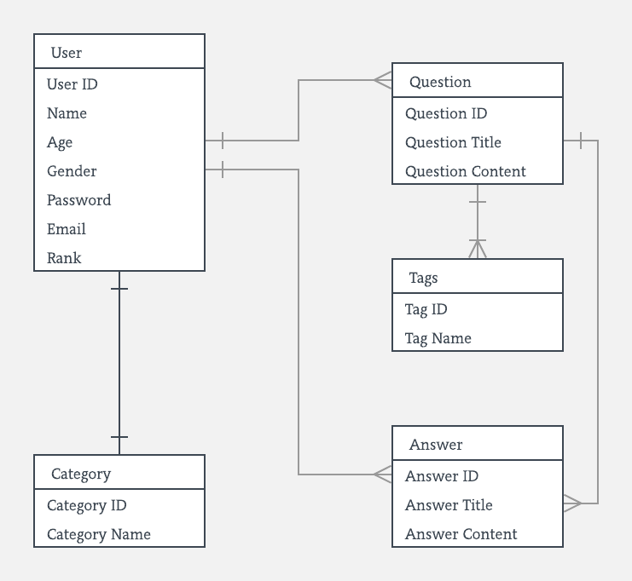

*Figure 3.5 Database Schema*

**References**

**References**

1. Tutorialspoint. SDLC-RAD Model. Retrieved from

https://www.tutorialspoint.com/sdlc/sdlc_rad_model.htm

1. Firger, J. (2014). 12 million Americans misdiagnosed each year. Retrieved from

[http://www.buzzle.comhttps://www.cbsnews.com/news/12-million-americans-misdiagnosed-each-year-study-says/](http://www.buzzle.comhttps//www.cbsnews.com/news/12-million-americans-misdiagnosed-each-year-study-says/)

1. Merab, E. (2015). Poor diagnosis blamed for cancer toll in Kenya. Retrieved from

<https://www.nation.co.ke/news/Poor-diagnosis-blamed-cancer-toll/1056-2811208-12bhk89z/index.html>

1. The Daily Nation.(2018)Baffling case of misdiagnosis that led to mother’s death.

|  |  |  |
| --- | --- | --- |
| |  | | --- | |  | |  |

<https://www.nation.co.ke/newsplex/medicalnegligence/2718262-4673818-t7jjajz/index.html>

1. Sherve, John.(2016)The high cost of medical errors

<http://www.indiaclinic.org/high-cost-of-medical-errors>

1. DataFox. (2018) The competitors of Docquity

<https://datafox.com/competitors/docquity>

# Appendix A: GANNT Chart

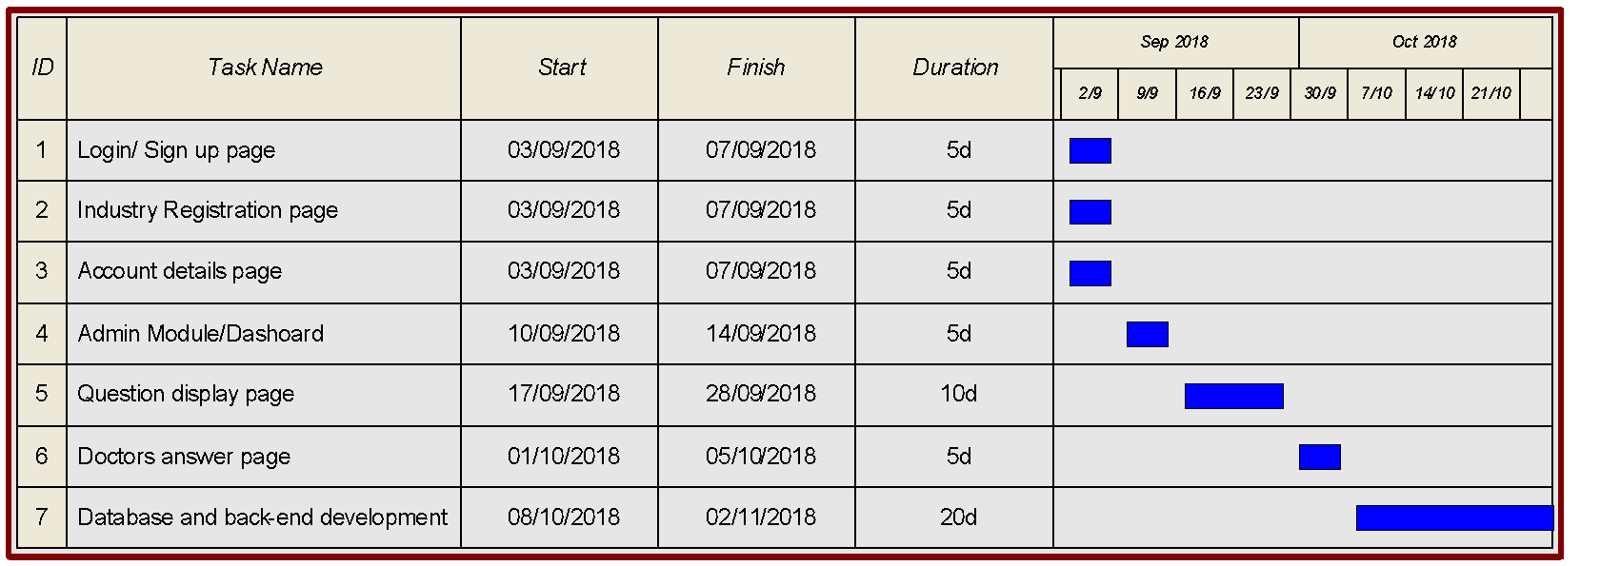

ICS Project I

Academic year 2018

Project Proposal Assessment

Student

Numbers:



Project Title:





|  |  |  |  |
| --- | --- | --- | --- |
|  | Weight | Score | Notes |
| Title page:  Informative, concise and appropriate | 2 pts |  |  |
| Table of Contents  Present with page numbers corresponding to report | 2 pts |  |  |
| Introduction  Background  Problem Statement (Background, Clear*2, Gap Identified)  Objectives (SMART and Linked to Problem Statement) | (10 pts)  2  4  4 |  |  |
| Literature Review/Related Work  Are relevant literature/work consulted?  Is the literature cited properly?  Is the literature adequate? | (6 pts)  2  2  2 |  |  |
| Intended Approach/ Methodology  Is the choice of methodology introduced and supported?  Are the design diagrams accurate and representative?  Is there a clear, logical and well-planned approach to the project?  Is there a clear explanation of the tools and techniques used? | (11 pts)  2  5  2  2 |  |  |
| Proposal Presentation  Is there an abstract that concisely describes the project?  Are relevant references provided and formatted correctly?  Is there a clear and proper use of language?  Effective report structure (chapters and sections) and layout | (9 pts)  3  2  2  2 |  |  |
| Total Mark | 40 |  |  |

Verdict (Please tick) Accepted Reject

Comments

Signed Date